Title: Aging (backwards) - “Reverse time, forward learning”

Created by: Orsolya Czigler, Nikolett Nagyné Bage, Mária Berecz

Short description: This A2 (possible B1)-level lesson for primary school pupils uses a short video about a man who ages backwards to build vocabulary, listening, and sequencing skills. Learners express opinions through speaking and writing, supported by digital tools like Wordwall, LearningApps, to teach Diffit and Padlet, with learners’ reflections posted on Wooclap.

Languages activity is designed for: English, adaptable to other languages.

Age group:
- 0-5
- 6-10
- 11-18
- 19-25
- 26-64
- 65+

Level:
- A1
- A2
- B1
- B2
- C1
- Teacher trainees

Lesson Objectives:
- Developing students' ability to understand and talk about a fantasy story involving a man who grows younger.
- Using and identifying age-related vocabulary and basic sentence structures, e.g., old, young, baby, grow up, etc.
- Sequencing 3–4 key events in the story in chronological order using visual support.
- Expressing a basic opinion about the story using simple sentence starters (e.g., “I think…,” “It’s strange because…”).
- Writing 1–2 complete sentences about their personal opinion on the story.

Learning outcomes: By the end of the lesson, learners will have:
- used at least 5 new vocabulary items;
- completed a video task and a complex worksheet showing comprehension of the story’s timeline;
- shared a short opinion using a sentence frame;
- written/recorded and posted a basic 1–2 sentence reflection on a fictional story.

Skills:
- Listening
- Speaking
- Reading
- Writing
- Interaction
- Vocabulary
- Grammar
- Mediation
- Pronunciation
- Intercultural
- Plurilingual

ICT tools used:
- Wordwall for warm-up and vocabulary revision/practice
- LearningApps for pre-teaching vocabulary and drag-and-drop activities.
- To-teach and/or Diffit for guided viewing.
- Padlet for sentence sharing.
Duration in minutes:
- 15-30
- 30-60
- 60-90
- 90-120
- 120+

Will students be marked for this activity? No.

Timing: Learning activity planned for a 60-minute lesson.

Description of each stage of the activity:

Stage 1: Warm-Up - Vocabulary pre-teaching (7 mins)

- Wordwall activity - matching opposites/related words: https://wordwall.net/resource/94414896 [See Annex 1]

- Description: Introduces key vocabulary visually and interactively, preparing students for the video.
- Potential Challenges: Some learners may be unfamiliar with concepts like "backwards" or confuse adjectives.
- Suggestions: Use gestures or drawings; allow repetition and loud pronunciation practice.

Stage 2. Pre-task: Picture Prompt (10 mins)
- AI-generated images of an old baby and a young old man are shown to the class: https://learningapps.org/41348549 [See Annex 2]

- Questions to answer:
- What do you see?
- What is strange about the pictures?
- Pupils match the expressions to the picture parts

- Description: This stage activates background knowledge, introduces the story context, and engages curiosity through visual input.
- Potential Challenges: Learners may be shy to speak or confused by the surreal image.
- Suggestions: Scaffold with sentence prompts and allow pair discussion before class share.

Stage 3: On-task. Guided Video Viewing (25 mins)
- Students watch a video trailer [with a duration of 2:29 minutes] “The Curious Case of Benjamin Button by F. Scott Fitzgerald (Summary and Review) - Minute Book Report” on YouTube, available at: https://www.youtube.com/watch?v=x7hRKgELZRE
- Video also available on to teach_, where students complete a complete worksheet regarding the story: https://to-teach.ai/share/3qAbAoCMkDJjHphCZY:bxnA [See Annex 3]

- Description: This worksheet aims to enhance listening comprehension of the narrative structure, writing, and vocabulary skills. Students will first demonstrate understanding of the plot, then define key vocabulary, and finally analyze the story's main themes in writing. (The writing tasks can also be used as prompts for speaking practice or can be completed as homework.)
- Potential Challenges: Learners might miss information due to speed or vocabulary.
- Suggestions: Replay sections, and provide support before/after questions.

! At this stage, an additional worksheet created with Diffit is available for less confident pupils, featuring a simplified story summary along with easier multiple-choice, short-answer, and open-ended questions to support differentiation. [See Annex 4]
https://docs.google.com/forms/d/e/1FAIpQLSf9TxPaCID1WuaAAwEsYeQN-OnNGgzNBrAzvQe8AMAva0CW0A/viewform?usp=sharing&ouid=113355833240679898481


Stage 5. Speaking Activity (9 mins) - Padlet
- Pair or group discussions:
  - Would you like to grow younger?
  - What is easy or hard about this life?
- Students use sentence starters:
  - I think... / I like... / It’s strange because...
- Description: Encourages personal response, supports oral fluency using scaffolded structures. Pupils can use Padlet to post or record their responses.
- Potential Challenges: Low-confidence speakers or off-topic discussions.
- Suggestions: Provide clear models, limit options, and circulate for support.

Stage 6. Writing Task/homework on Padlet (7 mins)
- Each group posts 1 short sentence from the previous task and completes the following question:
  - I would/wouldn’t like to grow younger because...
- Description: Consolidates comprehension and allows creative expression in writing.
- Potential Challenges: Spelling issues or limited grammar range.
- Suggestions: The Teacher provides a sample post and recording on the Padlet surface.

Suggestions for learner assessment/self-assessment/feedback/peer feedback:
- Teacher observation and checklist during the class
- Self-assessment smiley chart at the end: "I understood the story”/ "I used new words" / "I wrote my idea."
- Padlet comments or likes for peer feedback (simple emoji or "👍").

Post-evaluation of the activity:

Success Criteria:
  - All students can post a few basic sentences.
  - Students complete the sequencing task with support.
  - The majority of students use at least 3 target words correctly.
Feedback Collection (2 mins):
  - Quick exit ticket: one word or emoji, possibly posted on Mentimeter wordcloud: https://www.menti.com/al5rhmxyu6eh

- How did you feel about today’s lesson?
- What is your main takeaway from today’s lesson?
  - Informal teacher notes based on engagement and language use.
Reflection Questions for Teacher:
  - Were learners engaged with the story concept?
  - Did students show understanding through output tasks?
  - Which tasks were most effective for comprehension and participation?


Attribution: Original activity from “Use of ICT in support of language teaching and learning (ICT-REV)”, European Centre for Modern Languages of the Council of Europe. www.ecml.at/ictrev
Annex 1: Wordwall activity
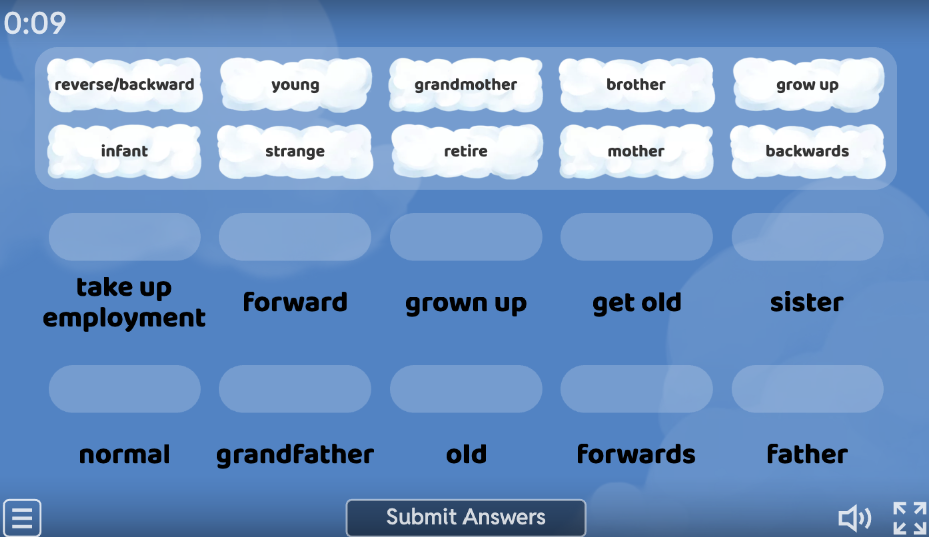

Annex 2: LearningApps activity
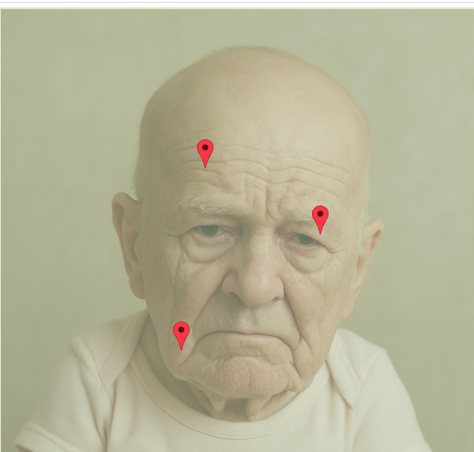
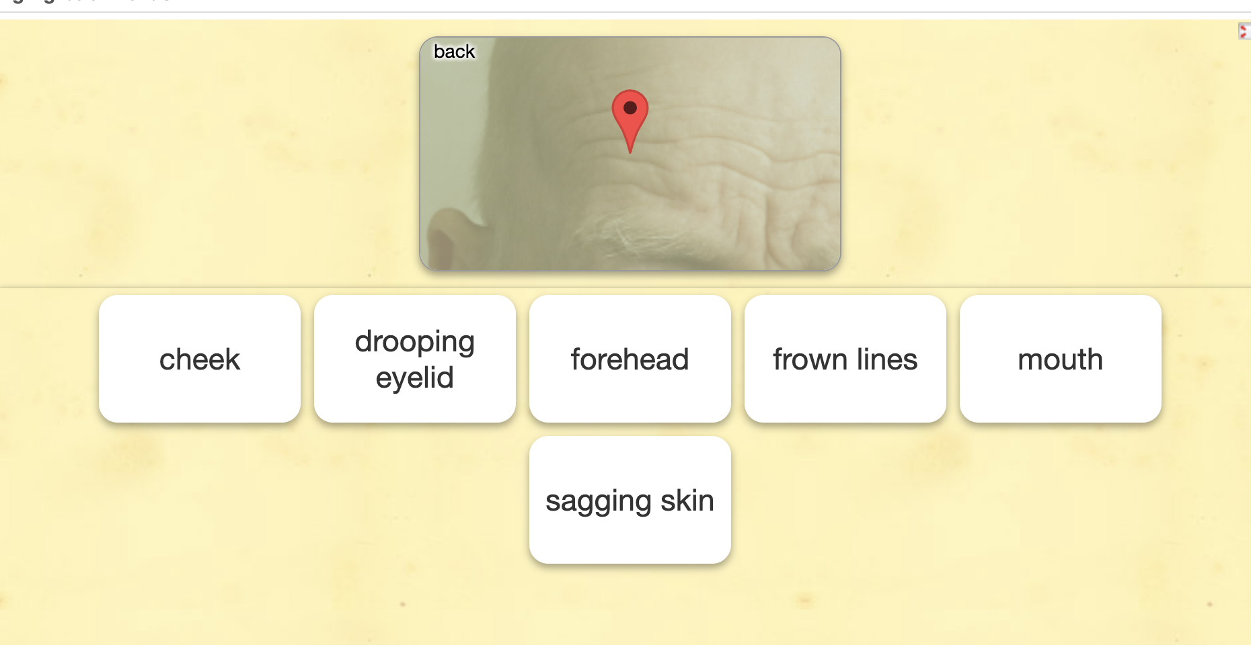



Annex 3: to-teach.ai activity
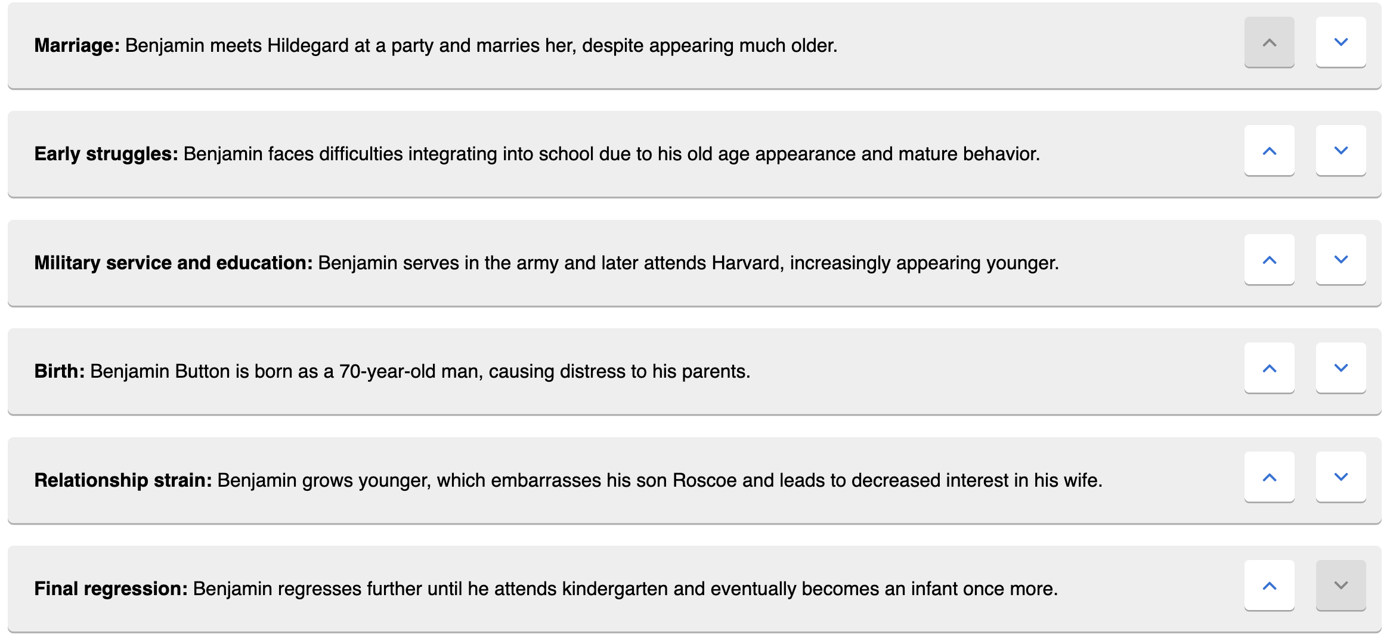
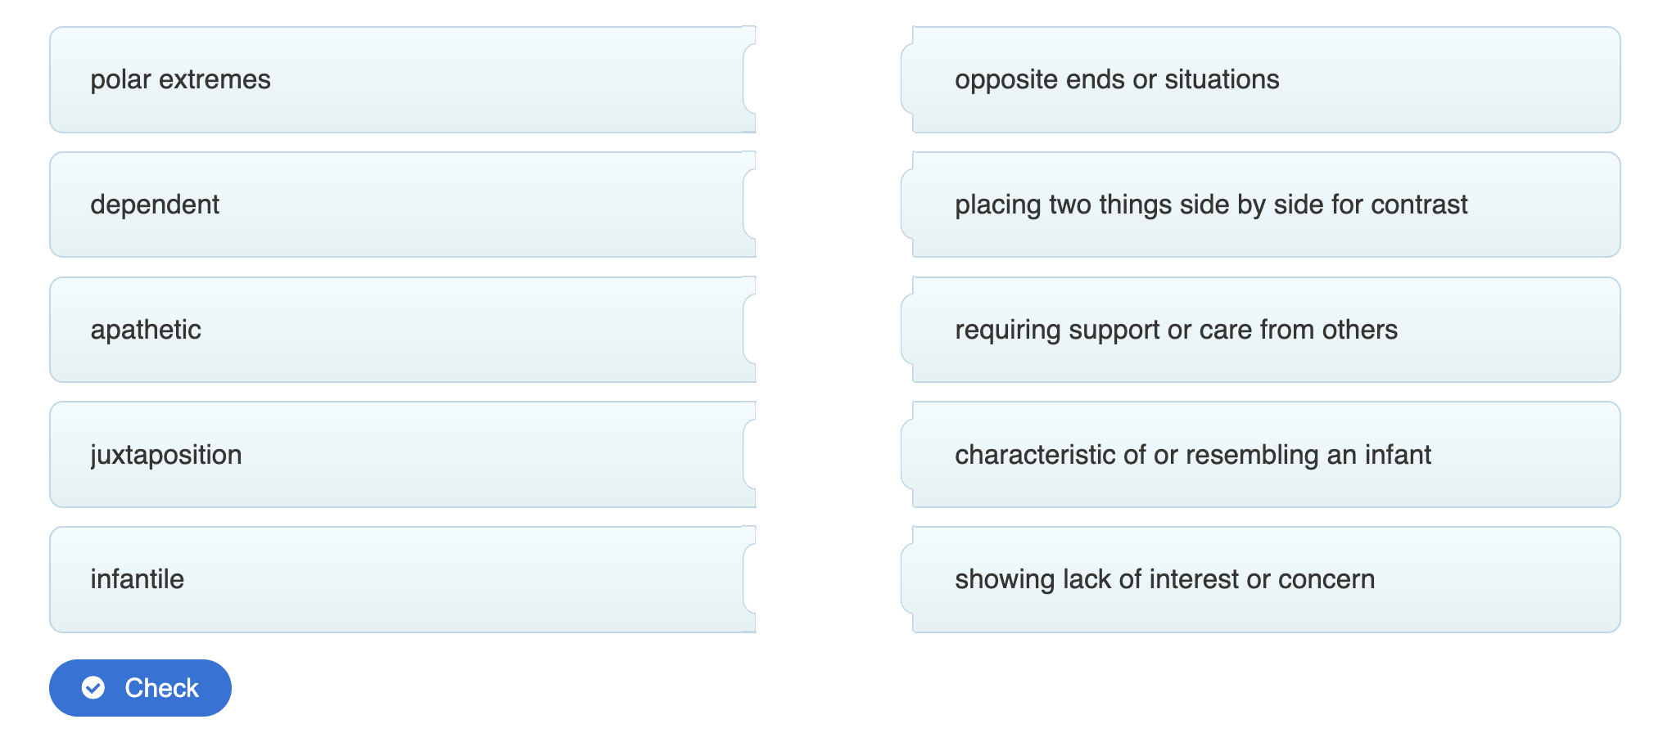
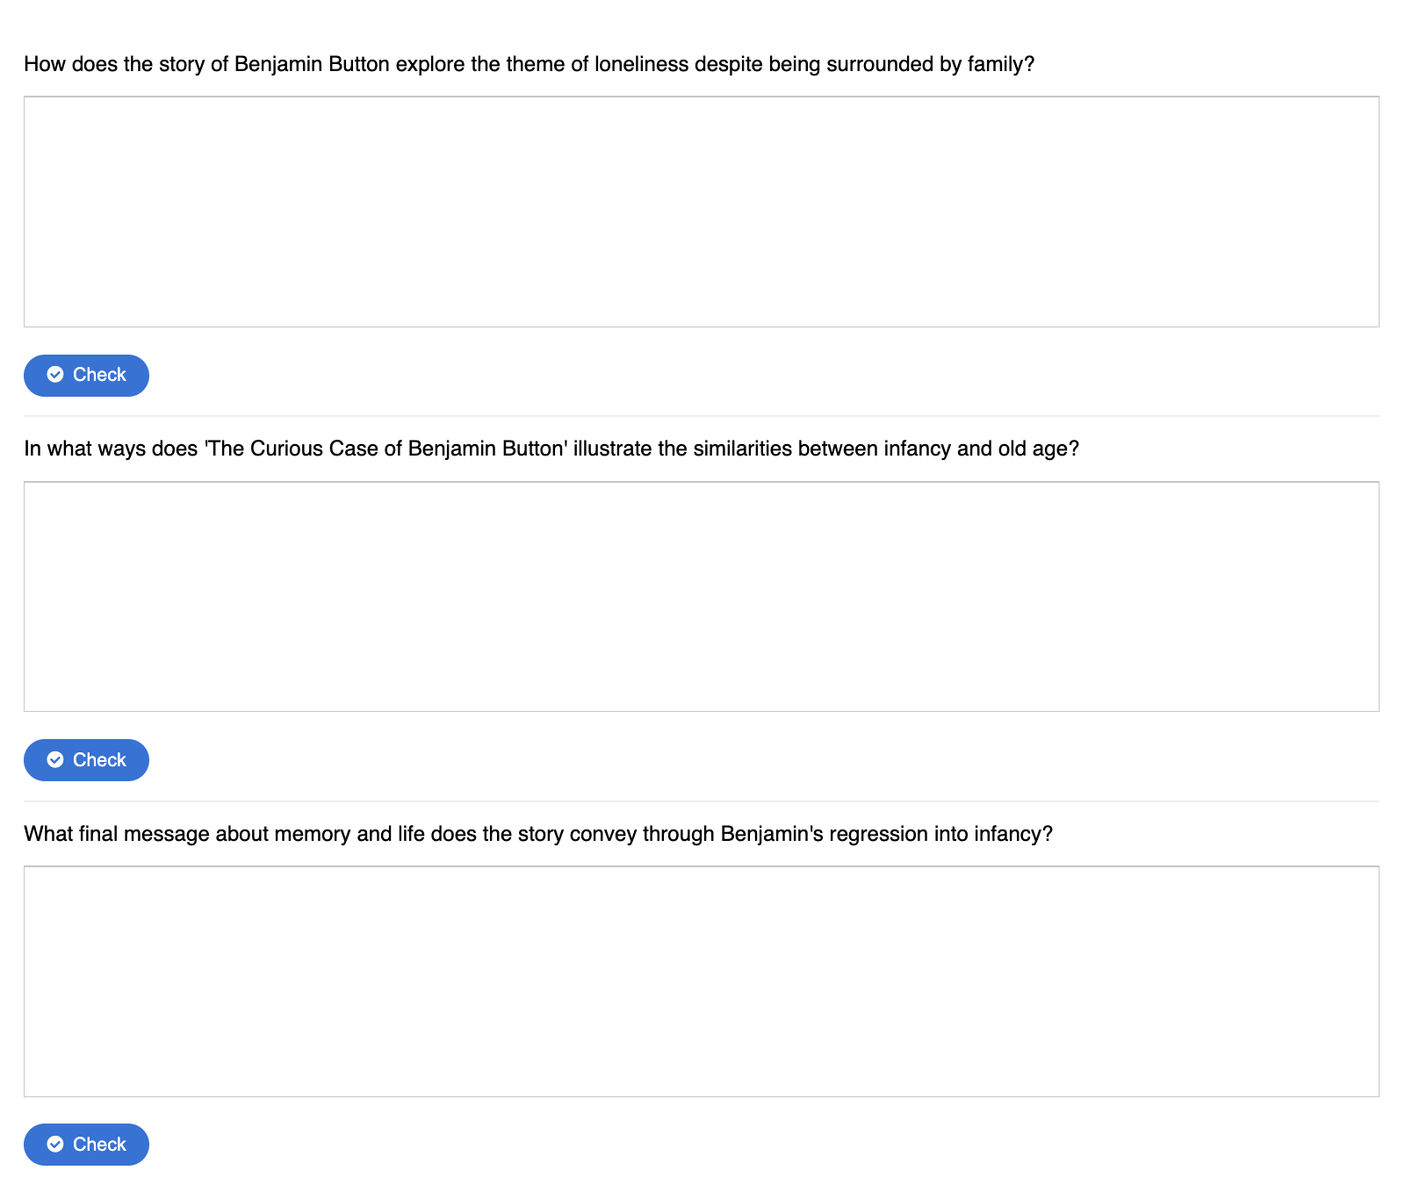
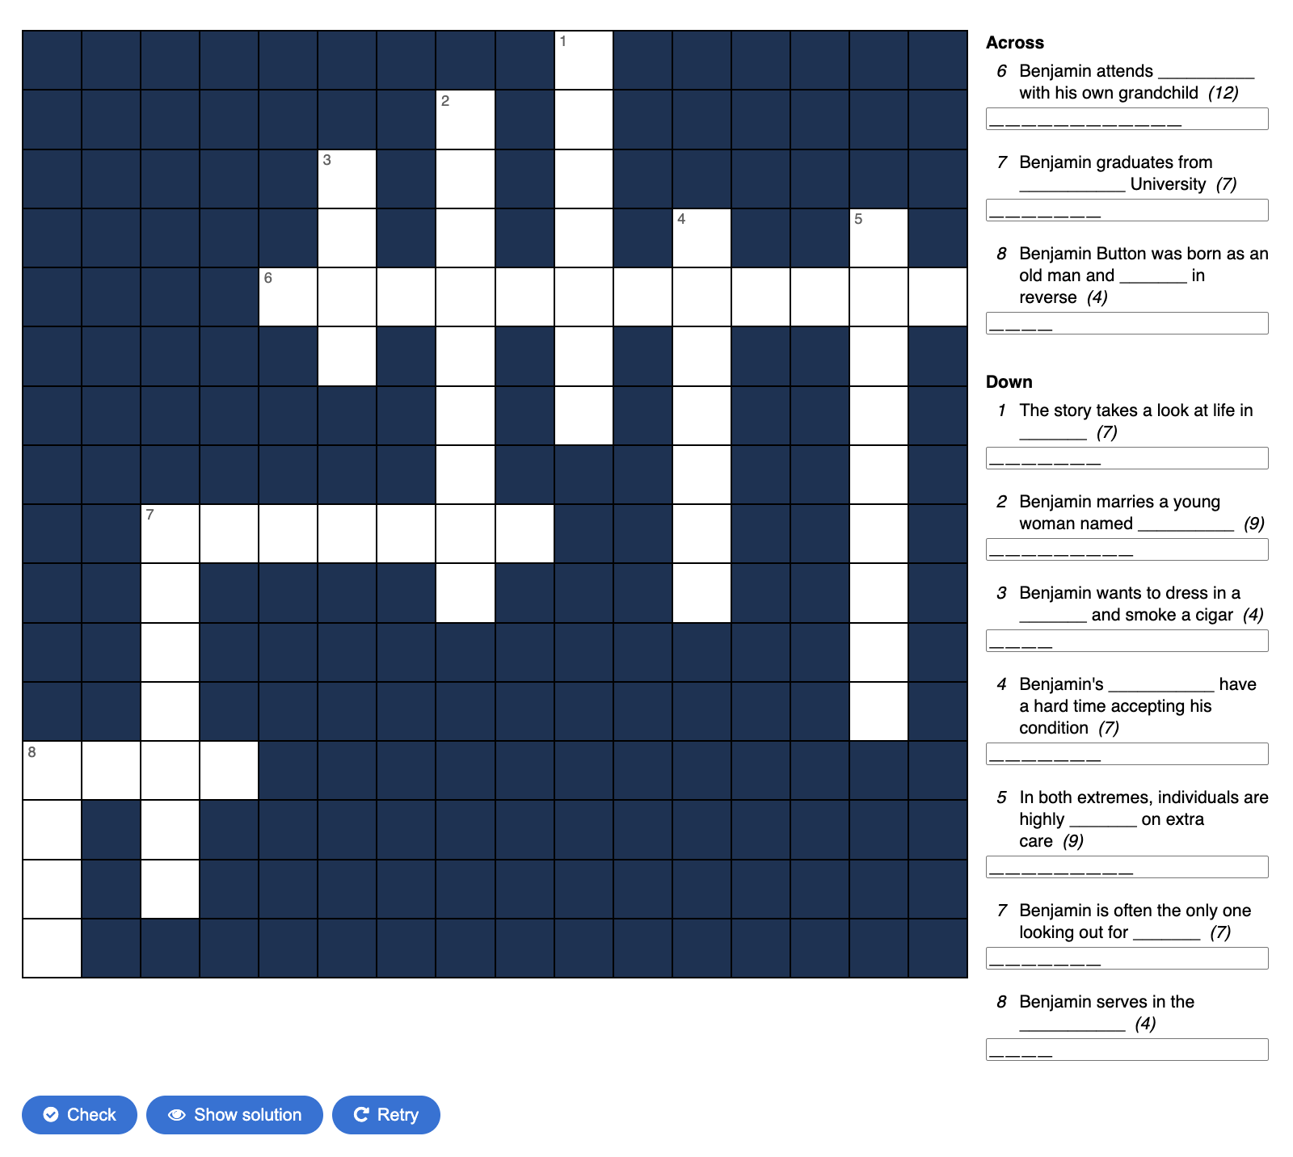

Annex 4: Google Docs Activity made with Diffit
